**Vertical Federal Software Manual**

Relates to software Version 2.0

This manual contains information pertaining to the use and operation of the Vertical Federal App software. It also outlines some limitations of the software

**Starting the software**

Prior to launching Vertical Federal App launch Lengthstds-Temperature-Monitor. In the File menu of Lengthstds-Temperature-Monitor open the following configuration file:

G:\Shared drives\MSL - Length\Length\Temperature Monitoring Data\Laboratory Configurations\VerticalFederalSetup.txt”.

Vertical Federal App requires access to this specific temperature log file. The app also needs up-to-date temperature data for the software to work correctly. Vertical Federal App will warn you if the file is not accessible and/or not up to date.

The Lengthstds-Temperature-Monitor should look something like this:

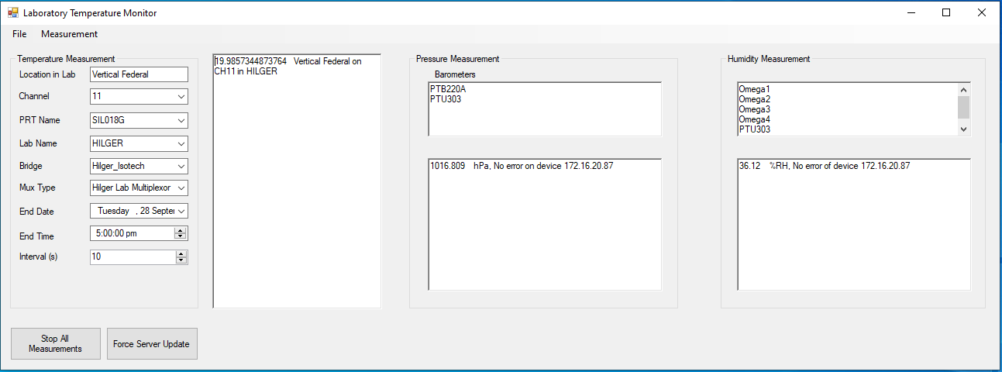

Once you are satisfied the Lengthstds-Temperature-Monitor software is actively logging to the correct file you are ready to open Vertical-Federal-App.

Launch Vertical-Federal-App

Vertical-Federal-App reads two files from the following hardcoded locations:

G:\Shared drives\MSL - Length\Length\Technical Procedures\config_uncertainty.ini

G:\Shared drives\MSL - Length\Length\EQUIPREG\cal_data.ini.

These files are converted to XML files and saved in the following locations:

G:\Shared drives\MSL - Length\Length\Technical Procedures\XML Files\

G:\Shared drives\MSL - Length\Length\EQUIPREG\XML Files\

The software will produce a new XML file name each time the conversion happens.

When the App launches you should see the GUI in the form below. The only active control at this stage will be the Federal Communication group box.

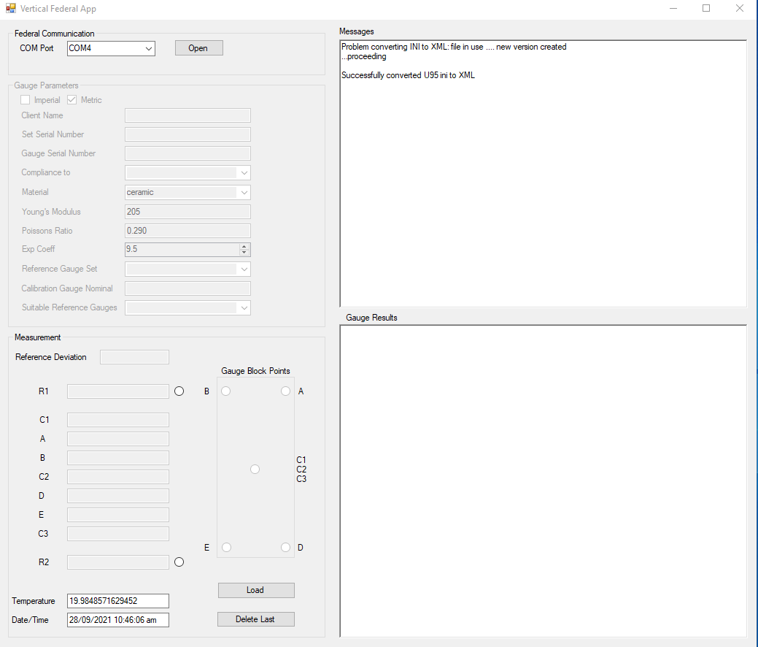

**Communication**

The communication interface for the vertical federal machine is RS232. The hardware will need a standard USB to RS232 DB9 cable for connection to a windows PC. This will need to be installed with appropriate drivers. To check which COM port is occupied by the USB to RS232 cable do the following:

Right click the Window Start Menu and click Search.

In the search box enter “Device Manager”.

In the Device Manager scroll down to “Ports” and open the dropdown arrow.

Find the USB to RS232 hardware and note the COM port number e.g COM4.

By default the software is set to COM4 but you can select a different COM port in the Federal Communication group box.

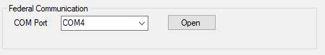

Once you have established the correct COM port number you can click the “Open” button. This action, if successful, should enable other controls in the GUI. However, you won’t be able to make any measurements until the calibration gauge parameters have been entered.

**Entering Gauge Parameters**

The gauge parameters group box contains metadata related to an individual gauge block. For each gauge block you measure you need to check that all these parameters are correct for that gauge. The parameters are used for calculations in the software.

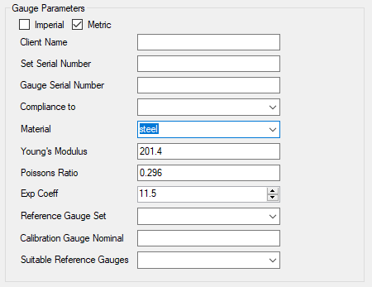

* *<Imperial> <Metric>* check box: Check the appropriate box according to whether the calibration gauge is Imperial or Metric
* *<Client Name*> Enter the name of the client that the gauge block belongs too. The text entered in the box here will be used to generate a filename for the output data.
* *<Set Serial Number>* Enter the gauge blocks set serial number. This can be any alphanumeric text.
* *<Gauge Serial Number>* Enter the gauge block serial number. This can be any alphanumeric text.
* *<Compliance to>* Select the compliance standard that the gauge block will be checked against. Compliance standard metadata is hard coded and is looked up from the selected string in the dropdown box. See the following functions in class Measurement.cs.

/// <summary>

/// fetches the allowable deviation and variation for imperial gauges

/// </summary>

/// <param name="l">enum representing the length range of the calibration gauge block</param>

/// <param name="st">enum representing the chosen documentary standard and grade</param>

/// <param name="ld">the limit deviation fetched</param>

/// <param name="vr">the variation fetched</param>

private static void FetchDevVarImperial(nom l, ComplianceImperial st, ref double ld, ref double vr)

/// <summary>

/// fetches the allowable deviation and variation for metric gauges

/// </summary>

/// <param name="l">enum representing the length range of the calibration gauge block</param>

/// <param name="st">enum representing the chosen documentary standard and grade</param>

/// <param name="ld">the limit deviation fetched</param>

/// <param name="vr">the variation fetched</param>

private static void FetchDevVarMetric(nom l, ComplianceMetric st, ref double ld, ref double vr)

* <*Material*> Choose the appropriate material for the calibration gauge from the dropdown menu. This will automatically populate the *Young’s modulus*, *Poisson’s ratio* and the *Exp Coeff boxes.* The chosen material has values associated with it as per the following code.

switch (materialComboBox.SelectedItem.ToString())

{

case "ceramic":

mtrl.exp_coeff = 9.2; //NIST Gauge Block Handbook

mtrl.poissons_ratio = 0.23; //NIST EMToolBox

mtrl.youngs_modulus = 200; //NIST EMToolBox

mtrl.material = "ceramic";

break;

case "steel":

mtrl.exp_coeff = 11.5; //NIST Gauge Block Handbook

mtrl.poissons_ratio = 0.296; //0.75% C hardened - Kaye and Laby "Tables of Physical and Chemical Constants", 16th edition

mtrl.youngs_modulus = 201.4; //0.75% C hardened - Kaye and Laby "Tables of Physical and Chemical Constants", 16th edition

mtrl.material = "steel";

break;

case "tungsten carbide":

mtrl.exp_coeff = 4.5; //NIST Gauge Block Handbook

mtrl.poissons_ratio = 0.2; //NIST EMToolBox 10% Cobalt - this agrees well with the opus website

mtrl.youngs_modulus = 599.84; //NIST EMToolBox 10% Cobalt - this agrees well with the opus website

mtrl.material = "tungsten carbide";

break;

}

Note: For Ceramic, our gauge block sets (21078P and 21080P) have a stated expansion coefficient of 9.5 x 10-6/°C. This differs from the value in the NIST Gauge block HandBook of 9.2 x 10-6/°C. It is assumed that the 9.2 x 10-6/°C is generally a more common value.

* <*Young’s Modulus*> This value is set when the material is chosen. You can enter a custom value if the gauge set has a specified Young’s Modulus.
* <*Poisson’s Ratio*> This value is set when the material is chosen. You can enter a custom value if the gauge set has a specified Poisson’s ratio.
* <*Exp Coeff*> This value is set when the material is chosen. You can enter a custom value if the gauge set has a specified Expansion Coefficient.
* <Reference Gauge Set> Choose which reference gauge set(s) you would like to use. The gauges are read from generated cal_data xml file. Gauge data is printed to the Messages window after you have made a selection. You can select more than one reference gauge set and any subsequent reference sets chosen will also be printed to the Messages window.
* <Calibration Gauge Nominal> Enter the nominal length of the calibration gauge. For metric gauges the length entered should be in millimetres. For imperial gauges the length entered should be in inch. If you enter a length which requires a reference stack to be made the software will calculate all the possible combinations of gauges that can be used to generate the reference stack. The software will also give you a reminder

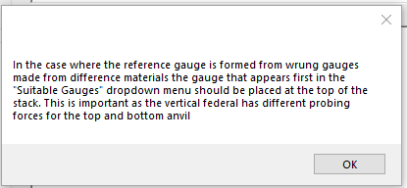

This ensures the elastic corrections are correctly calculated and highlights that the stack has a “sense”. However, if all the gauges in the reference stack are made of the same material, then the order of gauges in the stack is unimportant.

Note: Search Keys are formed in the software based on the *Calibration Gauge Nominal, Set Serial Number and Gauge Serial Number* according to the following *code.*

unique_id = m.CalibrationGauge.Nominal + m.CalibrationGauge.FromSet + m.CalibrationGauge.SerialNumber;

This specifies the uniqueness of a gauge. The unique id is used to search for previous measurements with that id. This allows multiple measurements on the same gauge block to be average and allows statistics to be calculated correctly. Keep an eye out for the case where there are two gauges in the same set which have the same nominal length and no serial number (this often happens when a set contains a tungsten carbide wear gauge). If this occurs, enter unique placeholder into the *Gauge Serial Number* box.

* <Suitable Reference Gauges> Once the Calibration Gauge Nominal has been entered the list of suitable reference gauge will be populated in the dropdown menu. Select the most appropriate (usually the least) combination of gauges from the list. In the case where the calibration gauge nominal length has a single matching reference gauge (i.e no stacking) the reference gauge is automatically selected. Once a reference gauge stack selection has been made the Measurement group box in the GUI will be enabled. The sum of the reference deviations of individual reference gauges used in the gauge stack should appear in the Reference Deviation textbox.

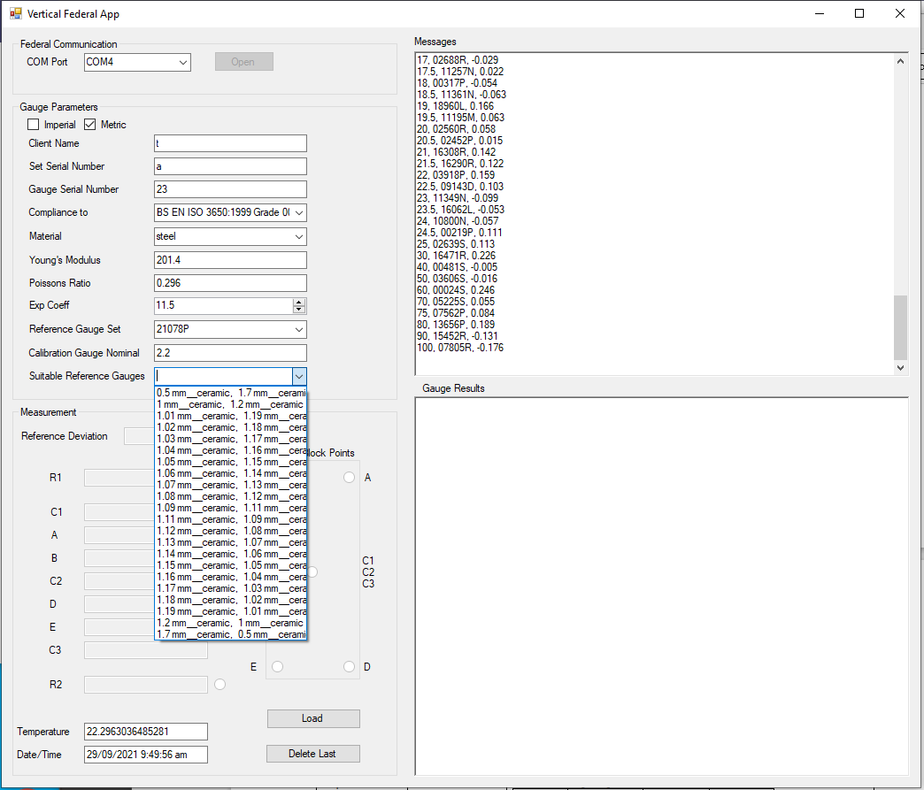

**Making a Measurement**

Measurements are made by using the foot control button under the Vertical Federal Bench. The measurement sequence is as follows:

*<R1*> The first measurement in the centre of the reference gauge.

*<C1*> The first measurement in the centre of the calibration gauge.

*<A*> The top right-hand corner of the calibration gauge.

*<B>* The top left-hand corner of the calibration gauge.

*<C2*> The second measurement in the centre of the calibration gauge.

*<D*> The bottom right-hand corner of the calibration gauge.

*<E*> The bottom left-hand corner of the calibration gauge.

*<C3*> The third measurement in the centre of the calibration gauge.

*<R2*> The second measurement in the centre of the reference gauge.

Corner measurements should be made such that the gauge block is properly supported as in the following images.

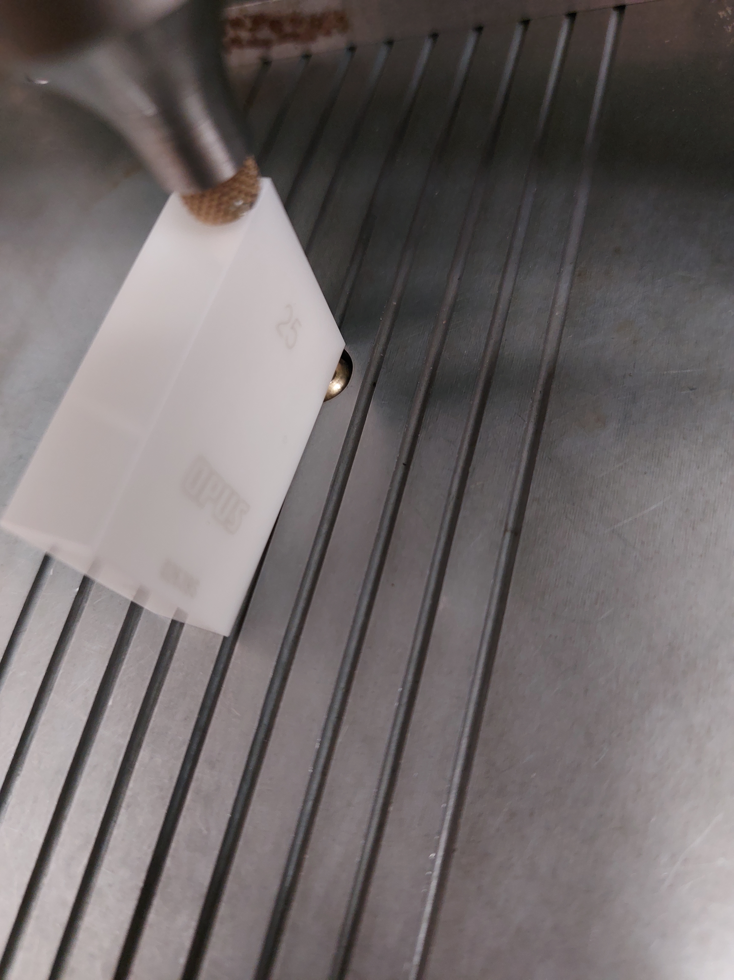 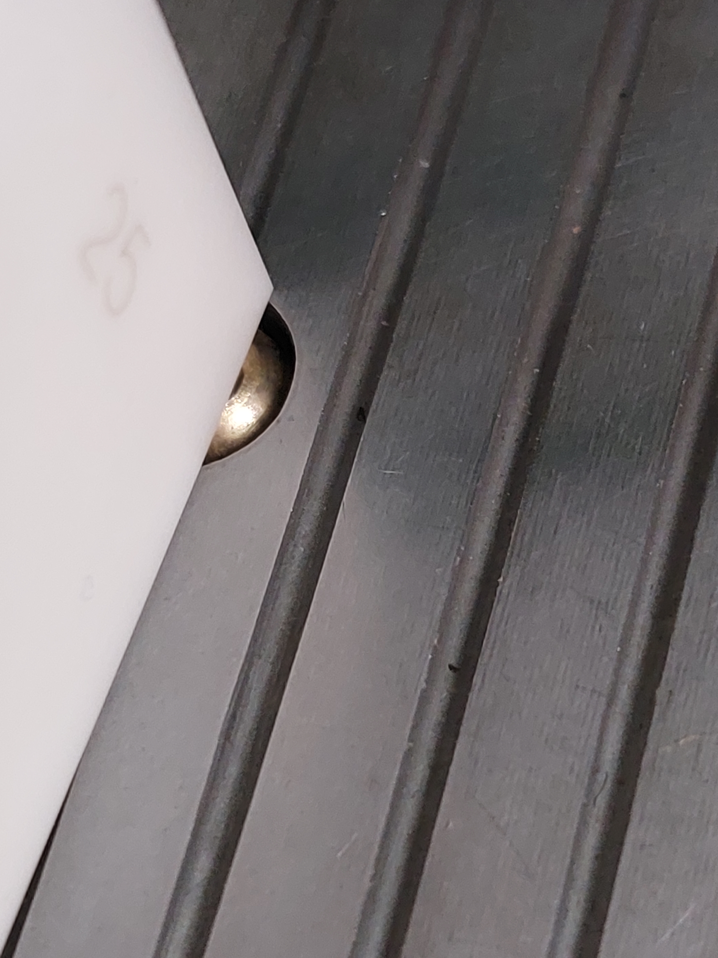

All corner measurements should be made with the gauge in the same footprint on the Federal platen. This reduces measurement error in the variation in length measurement caused by flatness errors in the Federal platen. This can be achieved by using a combination of rotating and flipping the gauge.

The current position in the measurement sequence is indicated by the black selection of the radio button as indicated in the following image. The current position in the measurement sequence can be changed at any time by selecting a difference radio button. To change to C1, C2 or C3 select the text as indicated in the following image.

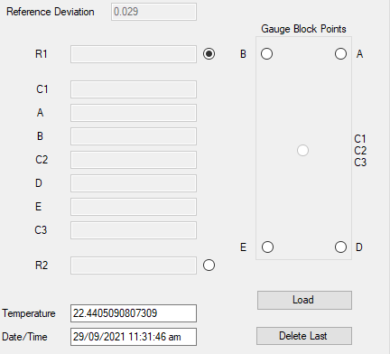

The measurement sequence is progressed by clicking the foot control on the vertical federal. When the measurement sequence reaches the final position (*R2*) and the foot control is pressed, a measurement will be registered. The measurement is then shown in the Gauge Results window.

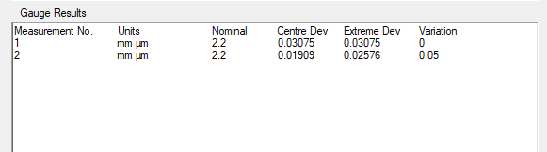

Gauge Results summarizes each measurement. It’s worth noting here that the values shown in this window are calculations of each individual measurement. This is an important distinction for the extreme deviation because it’s possible that extremes occur with opposite signs. For example, if the next measurement of extreme deviation for the 2.2 mm gauge was -0.02345 µm, then simply calculating the average of the extreme deviation measurements for the 2.2 mm gauge would be incorrect. This means this table is only giving a visualization to the user so they can see how each measurement has gone and how it compares with previous measurement.

**Saving Data**

The software will automatically saves progress every time a new measurement is added (a call to method SaveGaugeData(); upon a click of R2 on the foot pedal). The full data file is saved at the following location:

Measurement.filename = @"G:\Shared drives\MSL - Length\Length\Federal\FederalData\" + clientNameTextBox.Text + "_" + DateTime.Today.Year + ".txt";

The summary file and the U95 file are written to following location (these are also updated upon a click of R2)

Measurement.filename_sum = @"G:\Shared drives\MSL - Length\Length\Federal\FederalData\" + clientNameTextBox.Text + "_summary" + DateTime.Today.Year + ".txt";

Measurement.filename_U95_sum = @"G:\Shared drives\MSL - Length\Length\Federal\FederalData\" + clientNameTextBox.Text + "_U95_Compliance_summary" + DateTime.Today.Year + ".txt";

**Loading Data**

If are launching Vertical-Federal-App and you wish to load measurement data from a previous session then you need to click the “Load” button and select the measurement filename you wish to load.

**Deleting the previous measurement**

If you wish to delete the previous measurement you made then click “Delete Last”

**What’s the software is doing behind the scenes?**

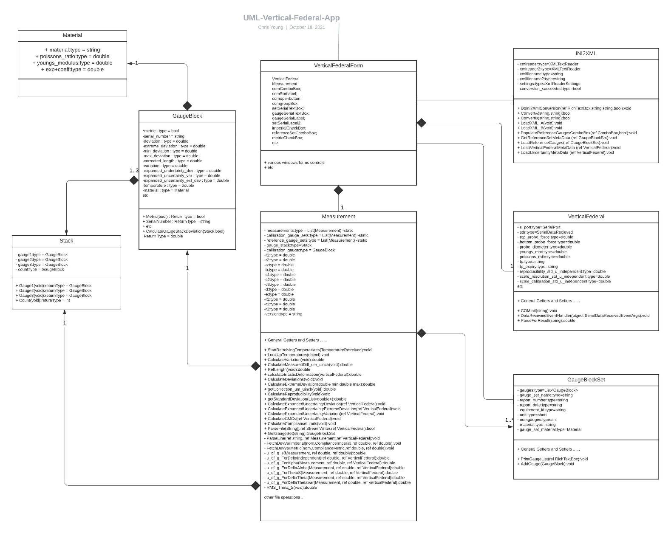

General description

The key method in the VerticalFederalForm Class is SaveGaugeData(). This function take all the user inputs and populates the metadata in the measurement object.

The software stores data associated with an individual measurement in the Measurement Class (Measurement.cs). Each measurement object has the following objects (and object lists) associated with it:

A static list of all the measurements we have taken.

private static List<Measurement> measurements = new List<Measurement>();

A *GaugeBlock* object to store the calibration gauge metadata.

private GaugeBlock calibration_gauge;

A *Stack* object which has three GaugeBlock objects associated with it. These GaugeBlock objects hold reference gauge metadata.

private Stack gauge_stack;

Every time a new measurement is added (a call to SaveGaugeData() occurs after a foot click of *R2*) the software does averaging calculations on all measurements with matching <unique_id> according to function *writeSummaryToFile()* in *Measurement.cs.* Measurements which are found to have matching *<unique_ids>* are used to update gauge block objects with the calculated averages*.* The extreme deviation is calculated from the average minimum deviation or the average maximum deviation depending on which has the largest magnitude. A summary file is written to:

G:\Shared drives\MSL - Length\Length\Federal\FederalData\

This software also updates the uncertainty for each gauge every time a measurement is added. The software calculates a pool standard deviation of repeat measurements for all gauges within the same set. This means the uncertainty will change every time a new measurement is added. It also means that there needs to be at least 10 measurements taken (even if the gauge set only contains one gauge).

Reference Standard Metadata

The software reads reference standard metadata for gauge blocks and the vertical federal from:

G:\Shared drives\MSL - Length\Length\EQUIPREG\cal_data.ini.

As an example, here is the metadata for the MSL tungsten carbide set (TC17118) :

[gaugeTC17118]

reportnumber = LENGTH/2017/1073

reportdate = 2017/08/15

equipregid = MSLE.L.037

unit = METRIC

material = tungsten_carbide

expcoeff = 4.5

youngs_modulus = 599.84

poissons_ratio = 0.200

std_uncertainty_dependent = 1.4

std_uncertainty_independent = 36.0

std_uncertainty_wringing_independent = 5.4

equiptype = GAUGE_BLOCK_SET

3.1 = , 0.014

6.5 = , -0.028

9.7 = , 0.072

12.5 = , 0.006

15.8 = , 0.027

19 = , -0.042

21.9 = , 0.021

25 = , -0.013

;

cal_data.ini also contains some constants specific to the Vertical Federal machine:

[verticalfederalcomparator]

reportnumber = Length/X/X

reportdate = XX/XX/XXXX

equipregid = MSLE.L.004

equiptype = GAUGE_BLOCK_COMPARATOR

top_probe_force = 3

bottom_probe_force = 1

probe_diameter = 0.25

probe_youngs_mod = 1160

probe_poisson_ratio = 0.143

;

Eventually, it would we should add an entry for the Vertical Federal scale calibration here.

Other non-specific uncertainty data the software reads

The software reads other uncertainty terms that don’t directly relate to equipment. These can be found in:

G:\Shared drives\MSL - Length\Length\Technical Procedures\config_uncertainty.ini

Here is the entry for the Vertical Federal:

[verticalFederal]

technical_procedure = MSLT.L.003.007

procedure_expiry = 26/06/2024

reproducability_std_u_independent = 0

scale_resolution_std_u_independent = 2.89

scale_calibration_std_u_independent = 8.0

stdu_delta = 5.3

stdu_alpha_g = 0.57735

stdu_delta_alpha = 0.816497

stdu_theta_s = 0.035

stdu_delta_theta = 0.057735

stdu_delta_theta_variation = 0.014434

expanded_u_cmc_dev_independent = 36

expanded_u_cmc_dev_dependent = 1.4

expanded_u_cmc_var_independent = 30

expanded_u_cmc_var_dependent = 0.35

;

Note: As is generally the case in other software I write configuration files are converted from .ini files to .xml so they can be parsed more easily.